Hand On Lab 1 : Installing Docker CE on Windows Server 2016

**Objective:**

**To learn docker support on windows server 2016 on Microsoft azure. This LAB uses azure VM with pre-installed Docker and TWO Base images.**

Duration **30 Minutes**

Prerequisites:

1. Azure Subscription
2. Internet Connection
3. Remote Desktop client (Built in Windows)
4. Web Browser (Any)

**Steps :**

1. **Create Windows Server 2016 with Containers VM**
2. Login into your azure portal (<https://portal.azure.com> )
3. Click on “Create Resource” to start creating new windows VM.

Search for “With Container”, portal should give you several suggestions, choose one “Windows Server 2016 with Containers”

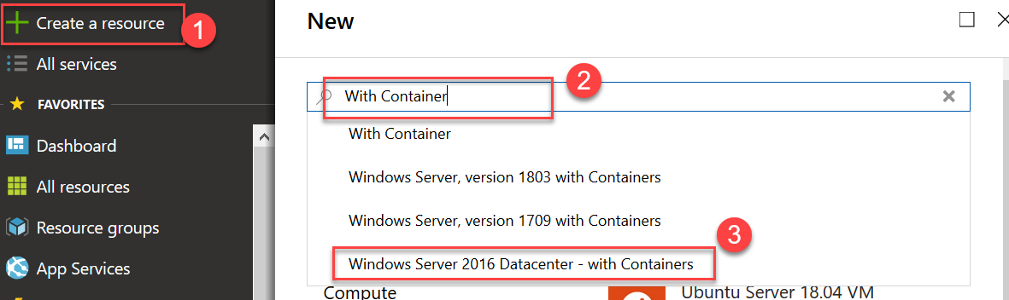

1. Now, in next screen click “Create” button to start VM Creation
2. In Basics tab, select an existing resource group or use “create new” button to create new one.

Then enter name of new VM : DockerVM1 and then scroll down for more settings.

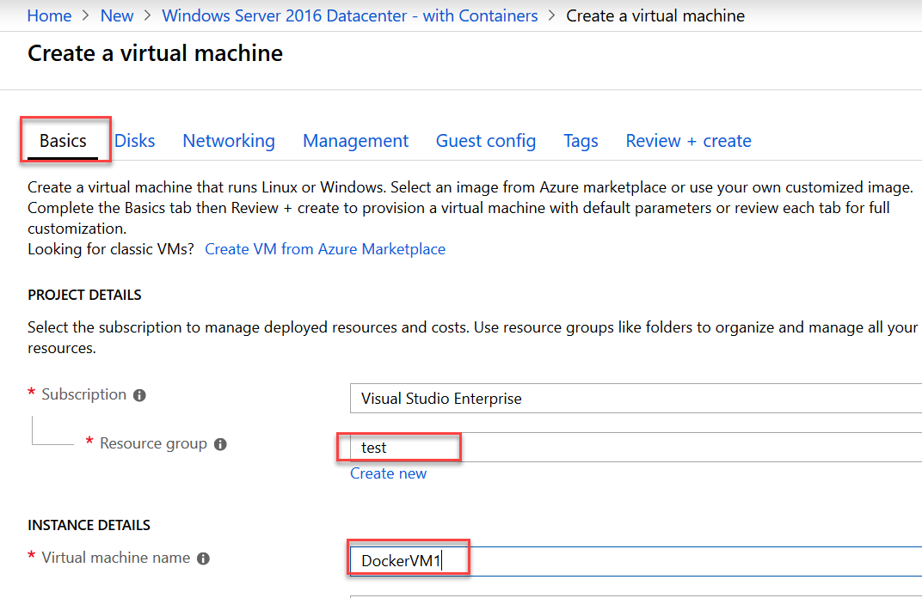

1. On next section, provide user credentials and port to be open for RDP access.

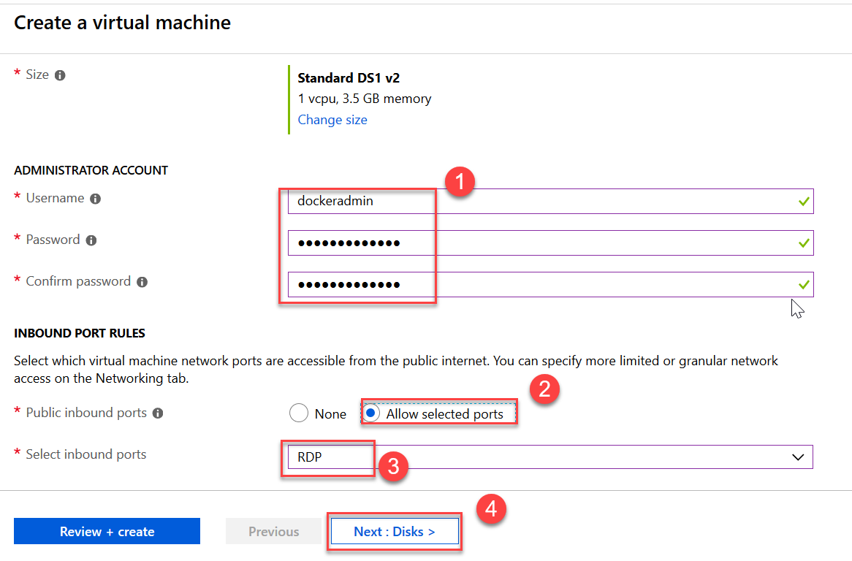

Click “Next : Disk ”

1. Again click “Next: Networking” to skip the disk configuration (Accept defaults).
2. Click “Next : Management” to skip networking (Accept defaults)
3. Now, Turn off both diagnostics and click “Review + Create”

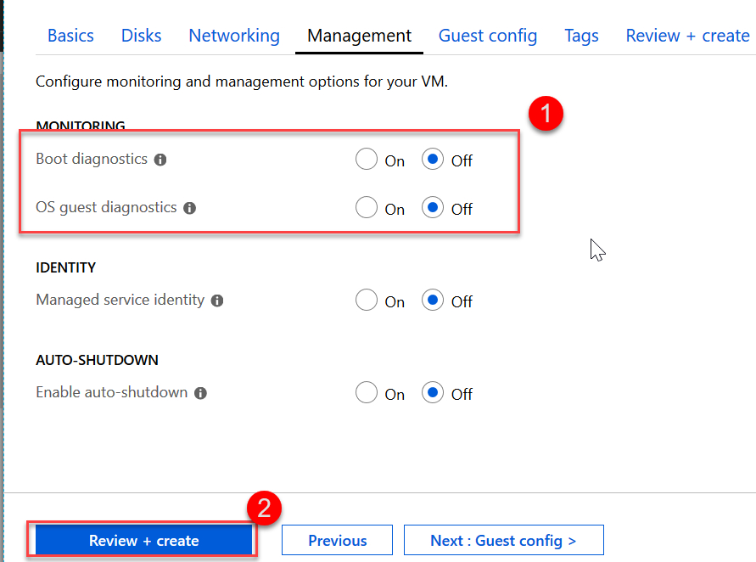

1. On final page, click “Create” button [Validation must be passed]

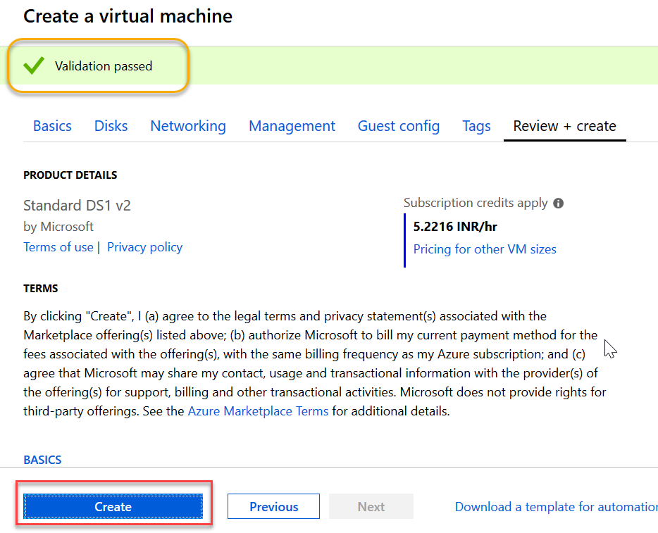

1. Wait for VM Provisioning to finish.
2. **Validate installation of docker, install docker-compose**
3. Once VM is Ready, Click on Connect button to start RDP Session

Choose “Use different account” in login box and then enter username & password.

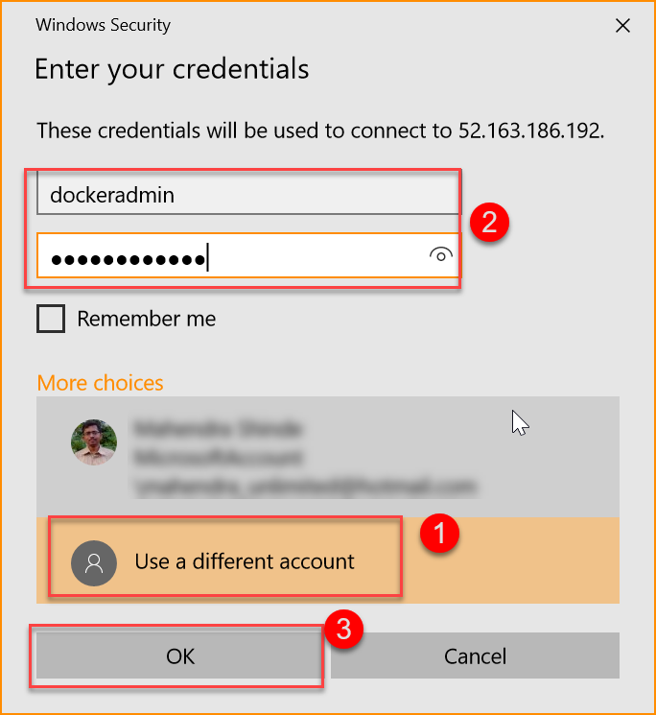

You may have to accept server certificate to begin session.

1. Now, Goto Start menu and click on “Windows Powershell”

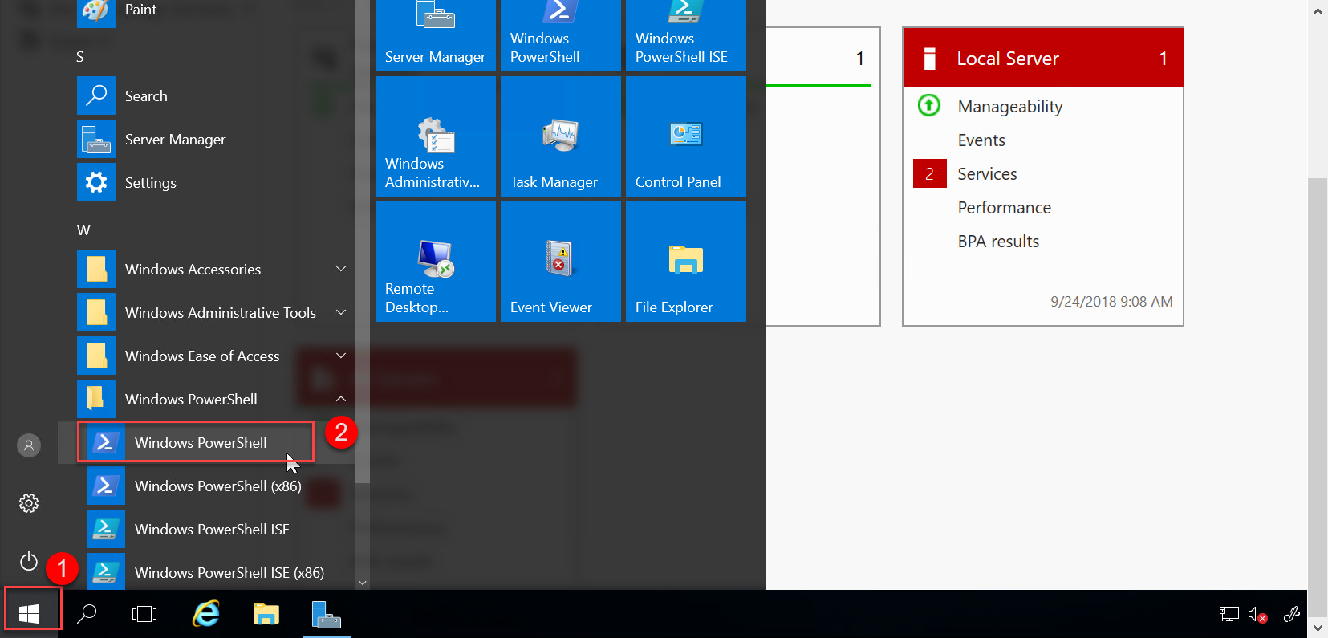

1. Try command “docker info” to test whether docker is installed.

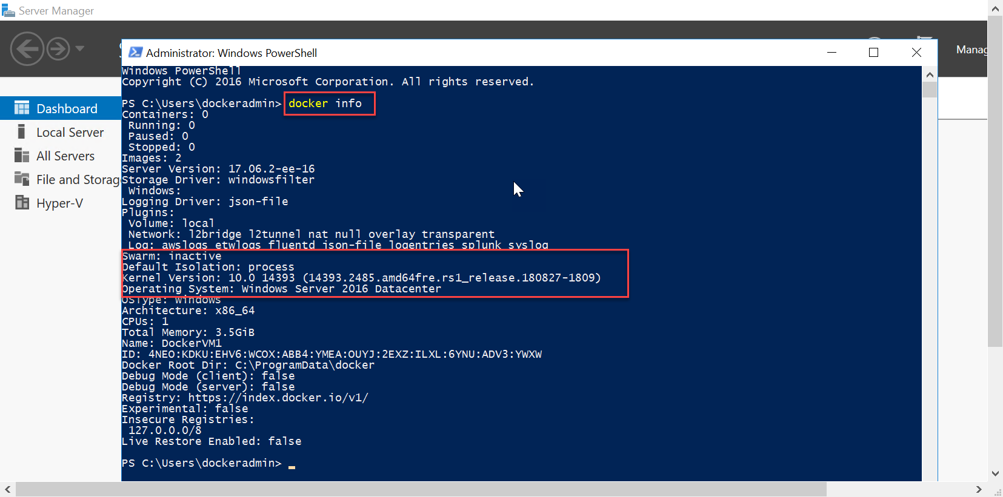

NOTE: You may use “cmd” instead of powershell to check if docker is installed.

1. To install docker-compose, open powershell



1. Type following commands to download from git hub

$ [Net.ServicePointManager]::SecurityProtocol = [Net.SecurityProtocolType]::Tls12

$ Invoke-WebRequest "https://github.com/docker/compose/releases/download/1.21.2/docker-compose-Windows-x86_64.exe" -UseBasicParsing -OutFile $Env:ProgramFiles\docker\docker-compose.exe

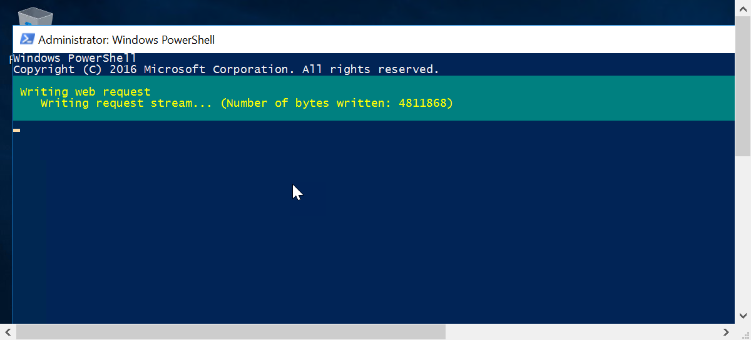

1. Once installed, docker-compose can be invoked from powershell or command prompt.

